Looking for complete solutions for banknote destruction?
This comprehensive video covers 3 major strategies and 7 specialized models trusted by central banks:

Solution A: Integrated Shredding & Briquetting
✔ (1/7) BM3002P-9075 – High-security integrated shredding & briquetting
✔ (2/7) BM6002P – Dual-stage shredding for high-capacity destruction
✔ (3/7) Models 5002 & 5001 – Shredding + baling combo
Solution B: Ultra-Fine 1mm Shredding System
✔ (4/7) 300BM1 – 600BM1 Series – Ultra-fine shredding (1mm) for P-6 compliance
✔ (5/7) Modular Systems 6002 & 4001 – Customizable with briquetting/baling
Solution C: Cost-Effective 1–3mm Shredding
✔ (6/7) QL300 – QL600 Series – Budget-friendly shredders from $2,000
✔ (7/7) SL500 – SL700 Series – Silent, high-security shredding for offices
👉 Learn more: www.yuedushredders.com

🌐 Contact Us
Shanghai YUEDU Technology Co., Ltd.
📞 Contact Us to explore more customized models and tailored shredding solutions that suit your specific needs!
Let us help you find the perfect equipment for your application.
📱 Sales Supervisor: +86 159 0178 2779 (WhatsApp / WeChat / Facebook)
📱 Administrative Supervisor: +86 137 6138 5116
📧 Email: yuedushredders@gmail.com | denghao8410@gmail.com
🌐 Website: www.yuedushredders.com
@YUEDUShredders – Empowering Global Industries with Intelligent Destruction Systems.

📄 （1/7）BM3002P-9075 Banknote Shredding & Briquetting System
Paper Shredder with Integrated Baler and Compactor
YUEDU Brand | Model: BM3002P-9075
Banknote Destruction Machine | Integrated Baler and Compactor | Output
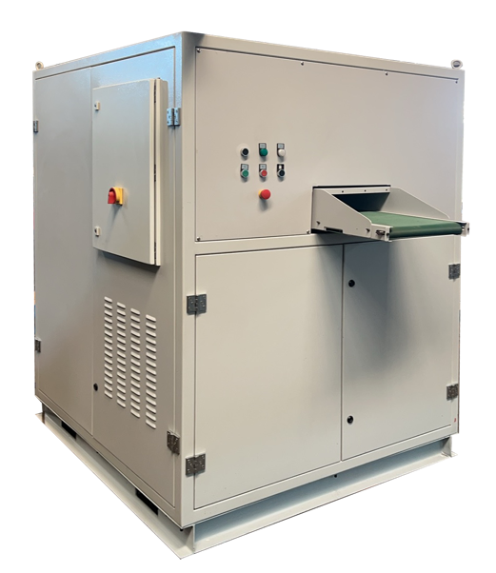 | 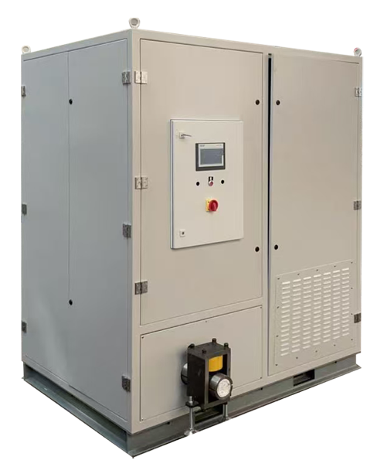 | 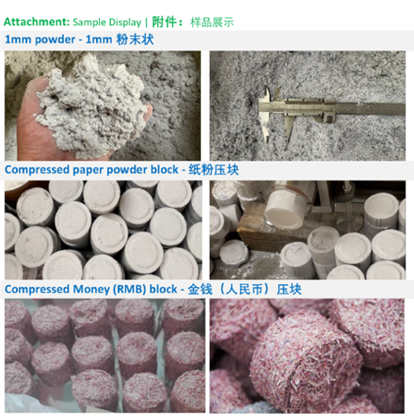
Shredder Specifications
• Single Feed Capacity: 100 sheets; Hourly Shredding Capacity: 100-150KG/H
• Feed Width: 420mm
• Power: 22KW
• Dimensions: 3380*1440*2220mm
Shredding Process:
• Two-stage shredding with dual blade sets.
• Dimensions: 1480*1440*1850mm
• Output: 3mm particles: 100-150KG/H; 1mm particles: 75KG/H
Compacting Process:
• Compressed block diameter: 90mm*40mm; Compacting output: 75KG/H
• Dimensions: 1900*1400*2220mm

User Case: Banknote Shredder and Compactor Combo Machine
Overall Image | Compactor Section | Output | YouTube video | 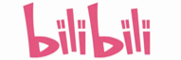bilibili video
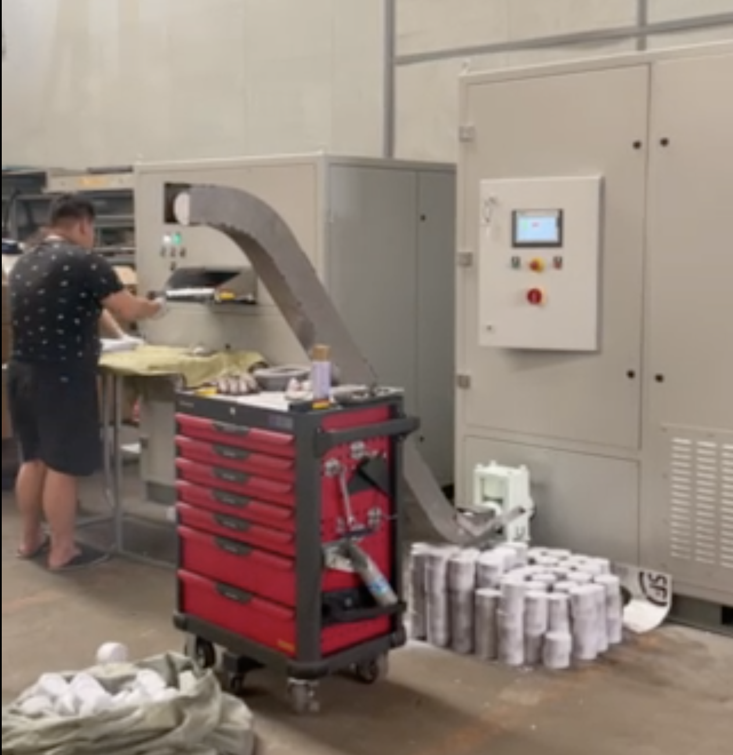 | 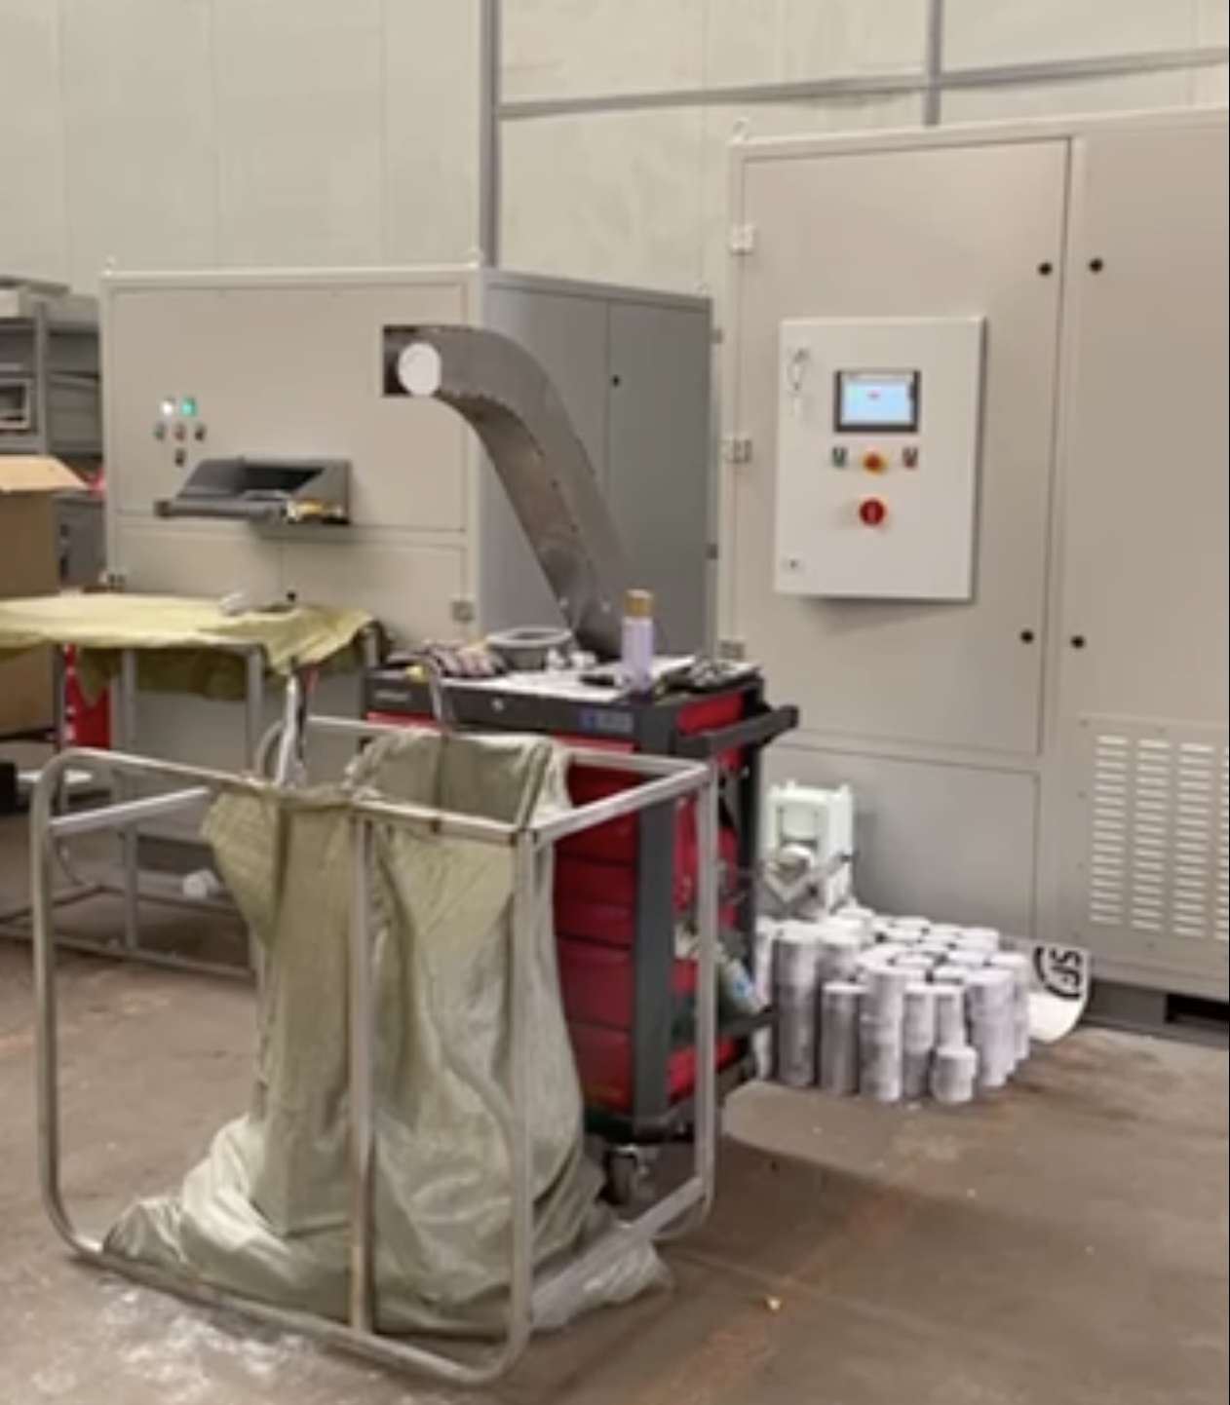 | 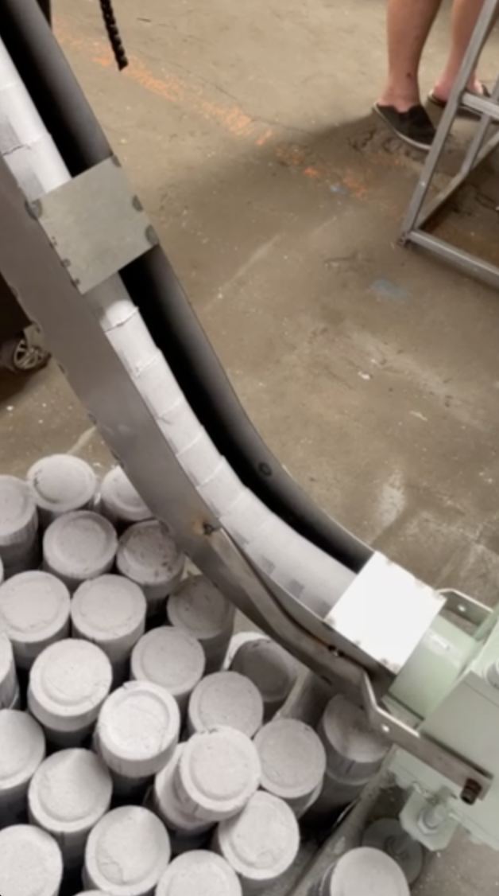 | https://youtu.be/OnOKqf-vkCA  https://youtube.com/shorts/5-dmXbM1Wpw | https://b23.tv/Go7TGFH  https://b23.tv/ToFqYLg

📄（2/7）YD-BM6002P Integrated Shredding System
All-in-One Shredding, Dust Collection & Baling System
Integrated system solutions for shredding, secondary processing, dust removal, and baling.
🖼️ Product Overview
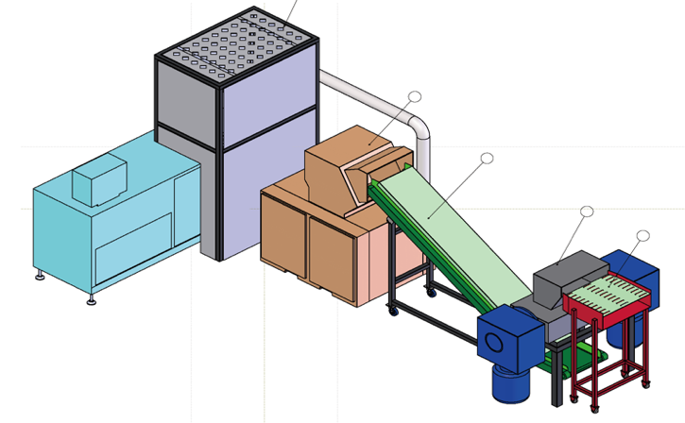 | 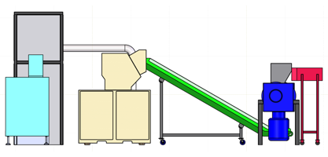
 | 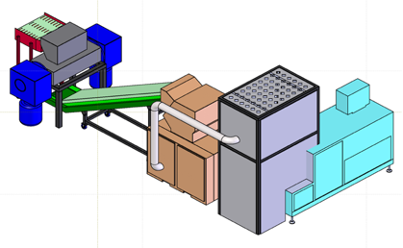
🧩 Application Scenarios
🔒🛡️Secure / Confidential Room
🔒🏭 Secure Destruction Center
💰 Product Pricing:
Shredder Unit – Model: YD-BM6002 → ¥497,731
Baler & Compactor Unit – Model: YD-DBJ6002P → ¥497,500
📏 System Overview: Three-View Diagram
(Front / Side / Top Views of the Integrated System)
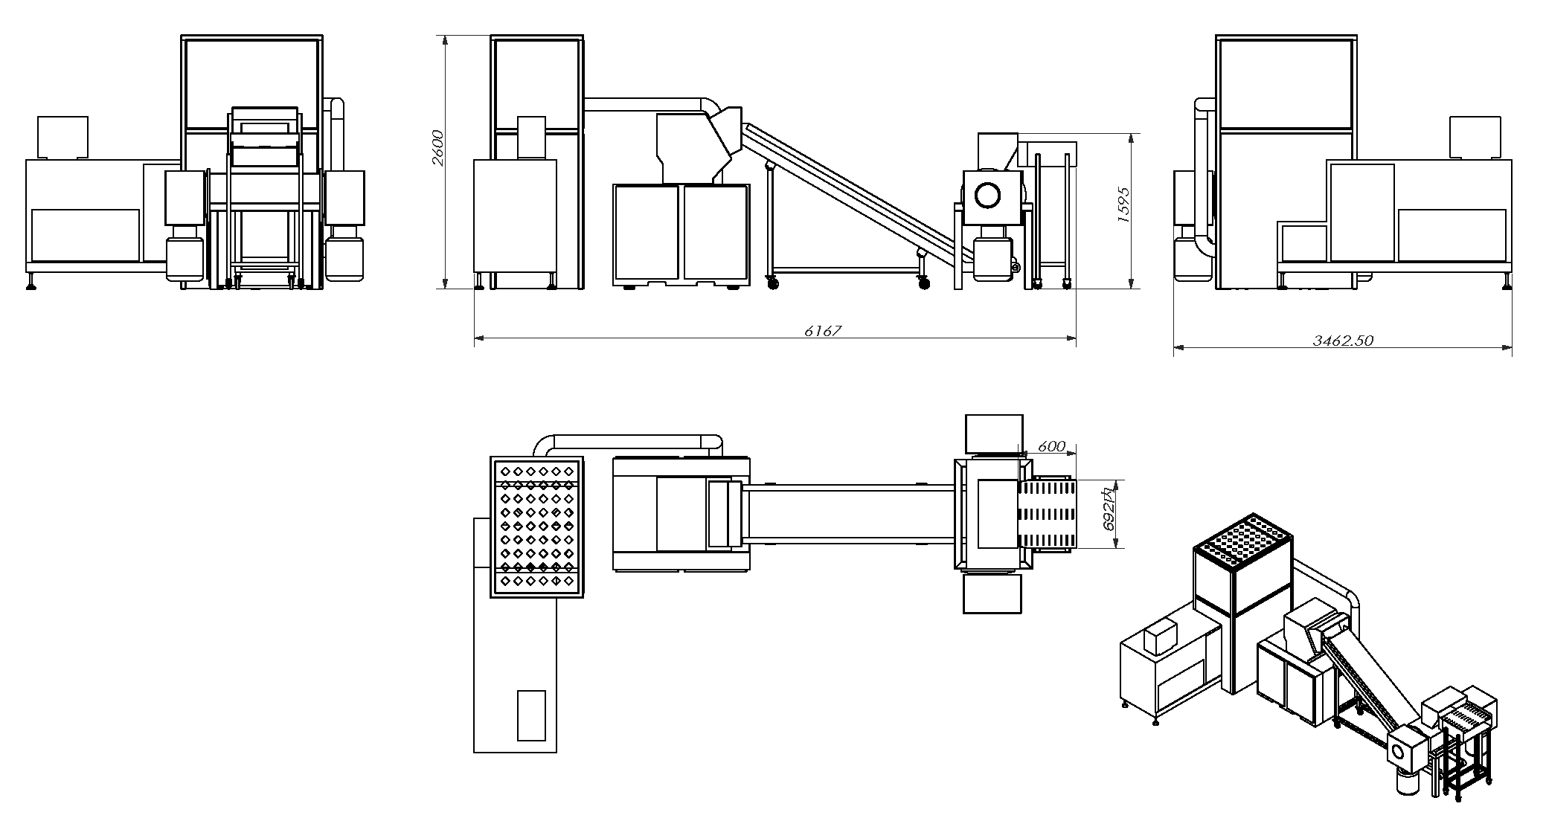
📌 Note:The above solution is for reference only. Final delivery is subject to the user’s confirmed requirements.

📄（3.1/7） YD-500CC2024 (500 pages)
🖼️ Product Overview
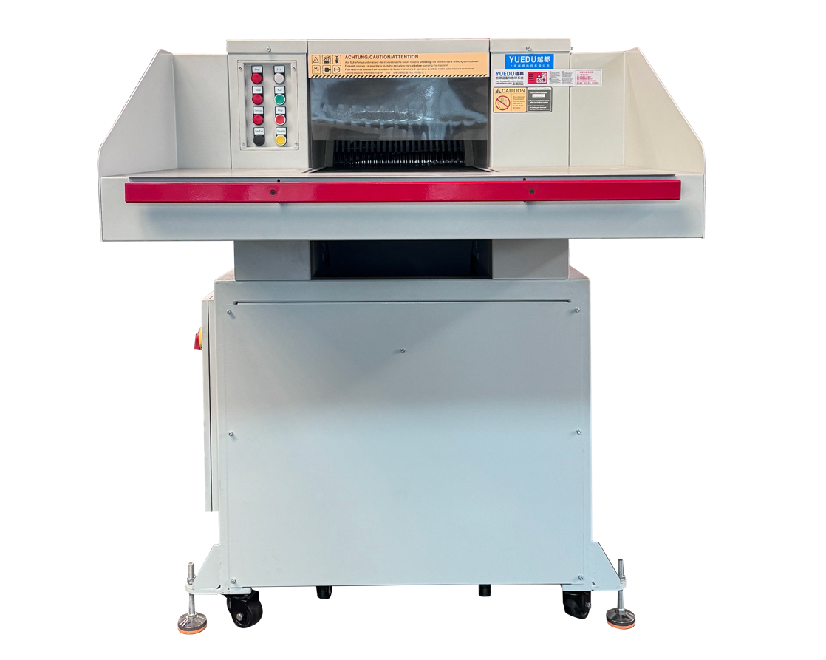
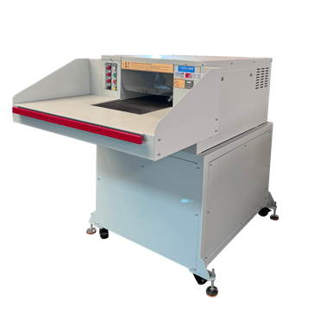 | 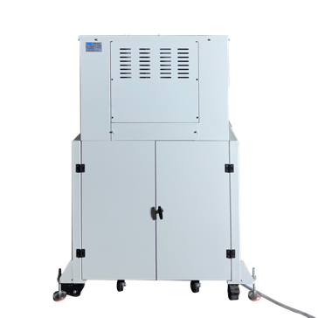 | 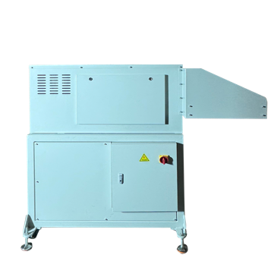 | 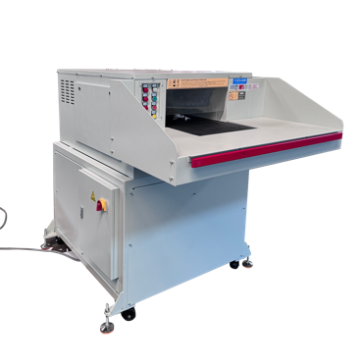
🔧 Technical Specifications：
🔒Security Level (DIN 66399) | P-2/O-2/T-2/E-2 | P-3/O-2/T-3/E-2 | P-4/O-3/T4/E-3 | P-5/O-4/T5/E-4/F-2
📥Feed Width (mm) | 500 | 500 | 500 | 500
✂️ Cut Size(mm) | 10.5x40-75 | 6x50 | 3.8x40 | 1.9x15
📑 Max Sheets | 500-550 | 340-380 | 180-200 | 90-100
⚖️Weight (kg) | 1200 | 1200 | 1200 | 1200
🔌Power | 7.5KW  3 x 400 V/50 Hz | 7.5KW  3 x 400 V/50 Hz | 7.5KW  3 x 400 V/50 Hz | 9.5KW  3 x 400 V/50 Hz
📏 L×W×H (mm) | 1318×1843×1638 | 1318×1843×1638 | 1318×1843×1638 | 1318×1843×1638
🗑️Bin(L) | 550L | 550L | 550L | 550L
💰Price (USD)
➕ Optional Add-ons:
Floor-mounted conveyor and rear baling system for efficient shredding and compact waste handling.

📄（3.2/7）YD-5002 Book Shredding & Baling Systems
🖼️ Product Overview
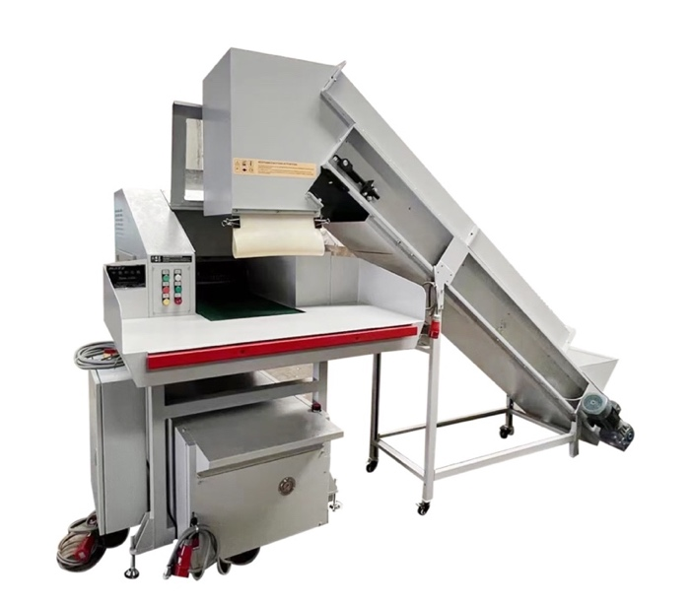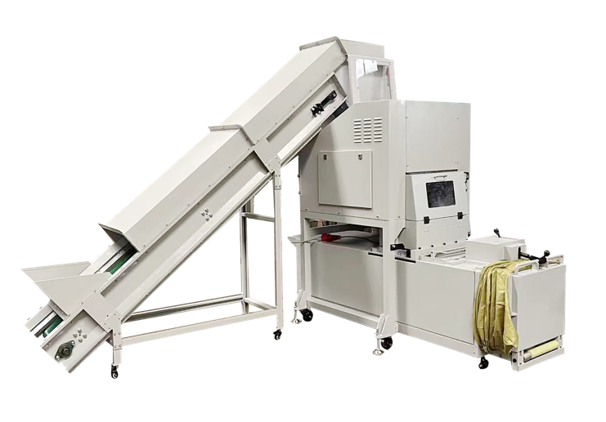
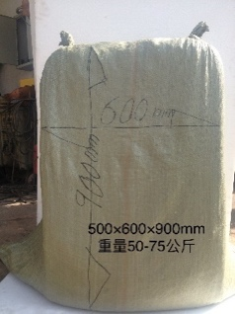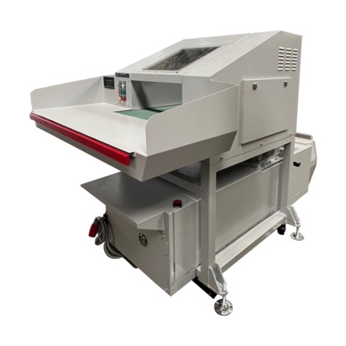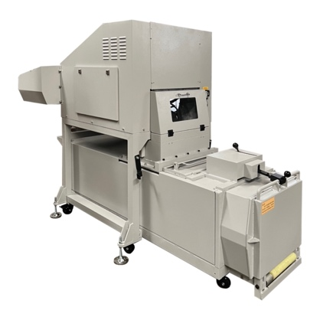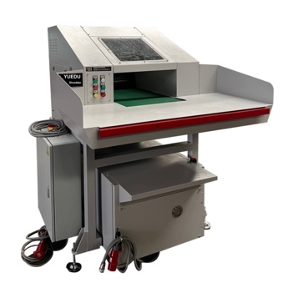
500CC shredder + 10T baler combo, ideal for secure rooms and archives.
Shreds up to 500 kg/h, compresses into 50–75 kg paper bales.
🔧 Technical Specifications：
⚙️Output/h: 500–600 kg
⚖️ Bale Weight: 50–75 kg
🧱Baling Pressure: 85 kN
🔌Power: 11.5 kW, 3 phase 400 V / 50 HZ
📏 L×W×H (mm): 3257*2588*2284
📐 System Overview: Three-View Diagram
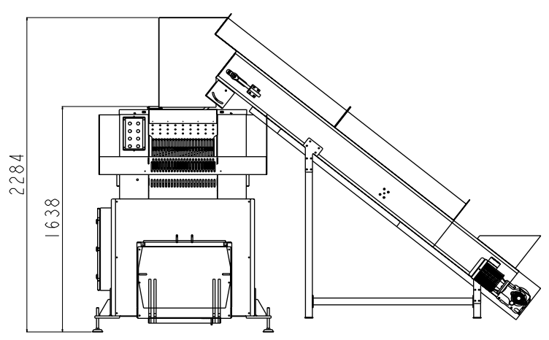 | 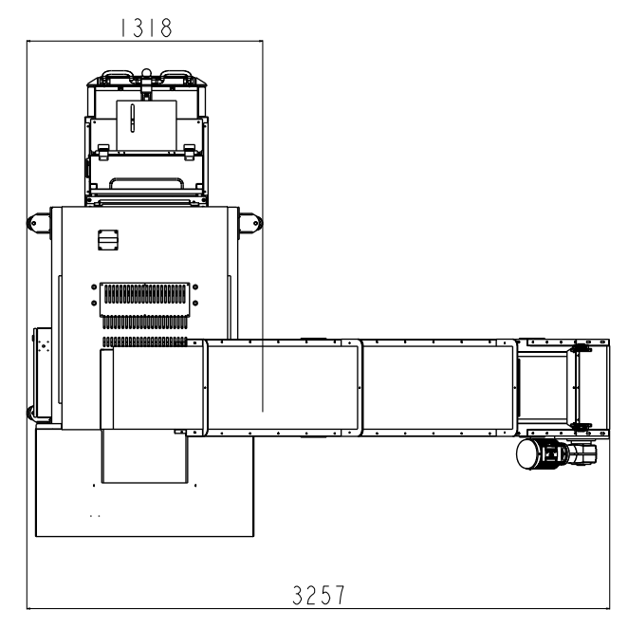 | 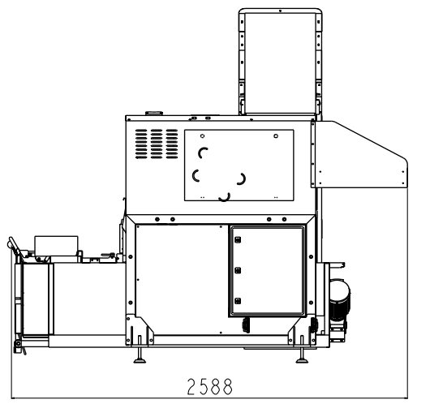

📄（4/7）YD-YTJ600BM1 500 400 300 – 1mm Ultra-Fine Shredders
🖼️ Product Overview
📸On-Site Usage | 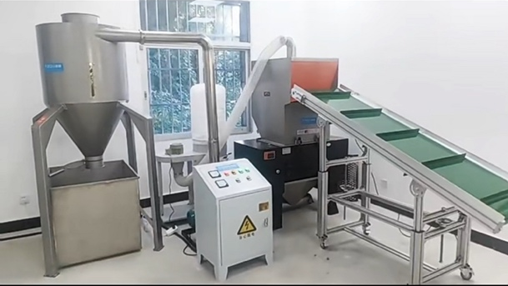
🌫️Shredding Result | 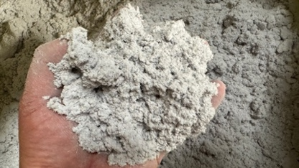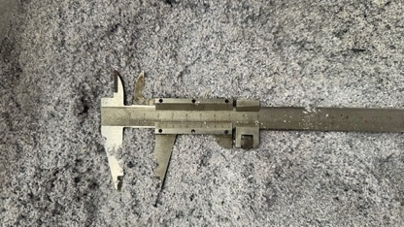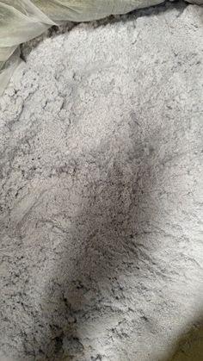
✂️ Shreddable Materials
Books and paper documents, CDs/DVDs
Cards and chip-based items (e.g. SIM cards, mobile chips)
PVC advertising boards, plastic display panels, KT boards, school and institutional event panels
Other paper- or fiber-based media
Other plastic-based materials
🔧 Technical Specifications
🆔Model | YD-YTJ600BM1 | YD-YTJ500BM1 | YD-YTJ400BM1 | YD-YTJ300BM1
📥Feed Width | 60CM*38CM | 50CM*30CM | 40CM*26CM | 30CM*22CM
✂️ Cut Size | 1*1mm粉末状，可调整粉碎尺寸为1*2mm, 8mm, 3mm等
📑 Max Sheets | 300-500 | 200-300 | 100-200 | 80-130
🔌Power | 19.12KW,3 phase 380V | 15KW,3 phase 380V | 10KW,3 phase 380V | 7.5KW, 3 phase 380V
💰Price (USD) | 29,610 | 21,150 | 21,150 | 17,143
➕ Custom Case
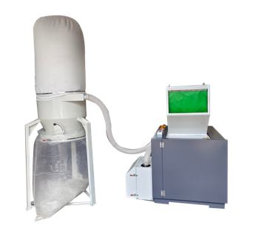 | 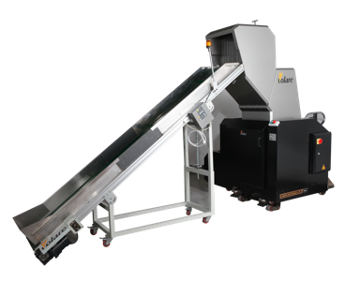 | 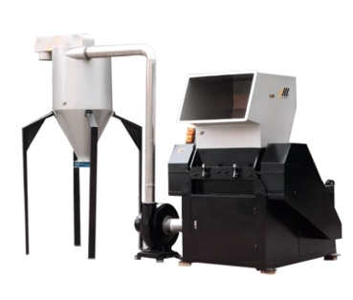 | 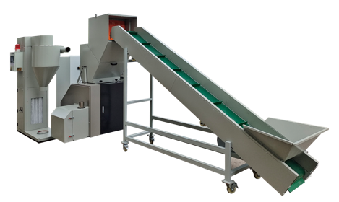

📄（5.1/7）YD-BM6002– Modular 1mm Shredding Solutions
🖼️ Product Overview产品概览
越都YD-BM6002机型（1*1mm粉末状）
适合场景 | 绝密销毁，保密1级销毁室，集中大批量粉碎涉密书本资料  案例：  某战区 保密室、某政府涉密销毁车间、某企业保密销毁中心
推荐原因 | A 保密程度高，可达到1*1mm粉末状（棉絮状）  B 粉碎效率高，速度快，有效的粉碎涉密单位的大量保密介质材料  C 可调整粉碎尺寸，适合多种销毁工况  D 可粉碎多种涉密介质，性价比高
型号 | YD-BM6002
价格 | 49.7731元
视频链接 | 【书本纸张絮状粉末效果：越都保密涉密销毁系统1mm粉末状效果】 https://b23.tv/Qqb6qwC
入口 | 1个
入口尺寸 | 60CM宽度、28CM高度
粉碎形状 | 1*2mm粉末状，80-100kg/hour  4~5mm粉末状，500 – 650kg/hour  8mm粉末状，1200-1600kg/hour  粉碎尺寸可调整
每次碎纸 | 300-500张
电压 | 380V
功率 | 27KW
可碎材料 | 光盘介质、卡片、芯片、存储介质、线路板、半导体介质
整机图  用户现场 | 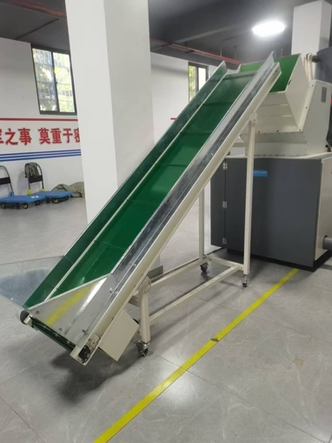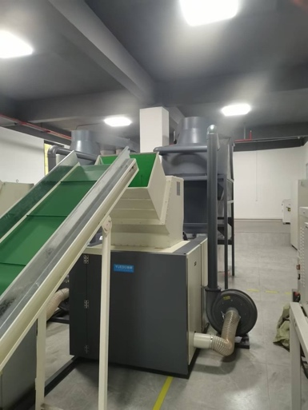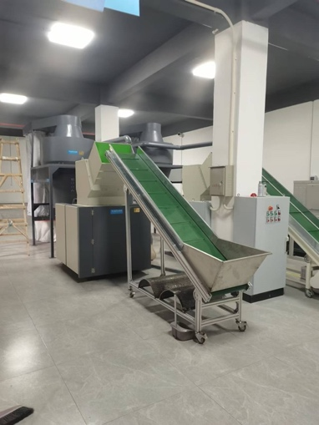

输送带进料。最小尺寸可以达到1mm粉末状。配套大吸力出料除尘系统，有效提升效率。

📄（5.2/7）YD-BM4001 – Modular 1mm Shredding Solutions
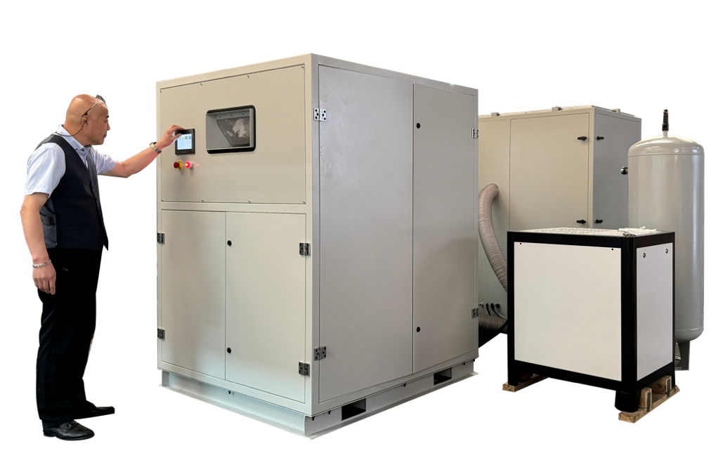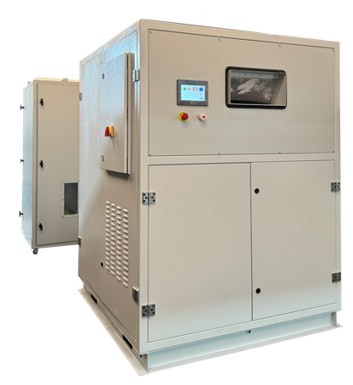

1mm powder - 1mm粉末状
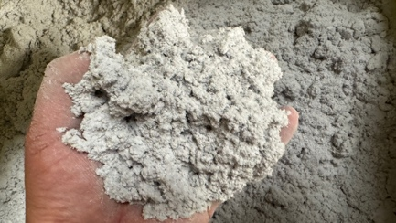 | 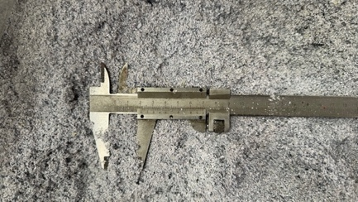 | 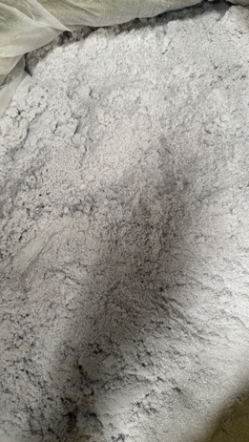
Shredder Specifications:
• Single Feed Capacity: 100 sheets; Hourly Shredding Capacity: 100-150KG/H
• Output: 3mm particles: 100-150KG/H; 1mm particles: 75KG/H
 https://www.youtube.com/watch?v=Kc4YdBsiQKo
➕ Custom Case定制案例
Banknote Destruction Machine | Integrated Baler and Compactor | Output
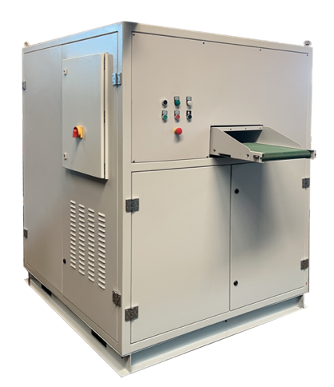 | 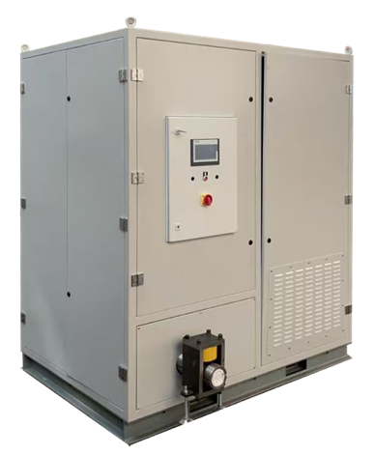 | 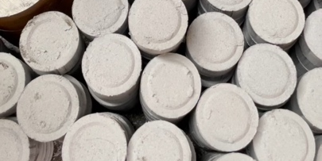 | 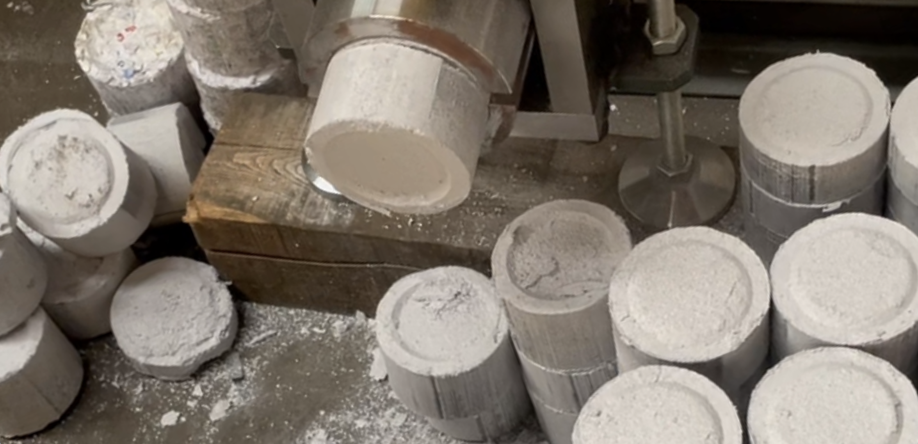
 |  | 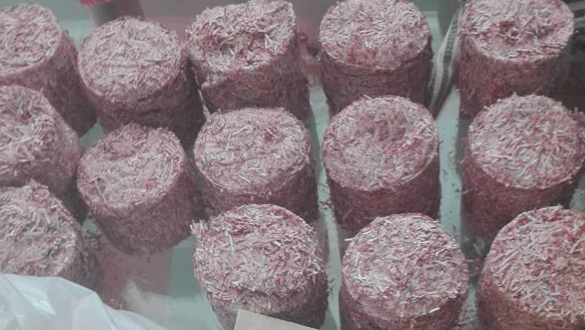 | 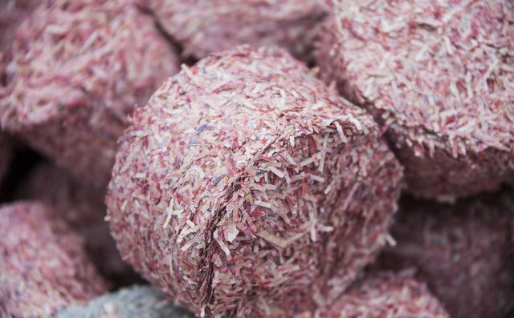

Video1: https://youtu.be/OnOKqf-vkCA Video2: https://youtube.com/shorts/5-dmXbM1Wpw

📄（6/7）YD-FSJQL系列 300-800型漏斗大功率机型
🖼️产品概览Product Overview
YD-FSJQL300 | YD-FSJQL400 | YD-FSJQL500 | YD-FSJQL600
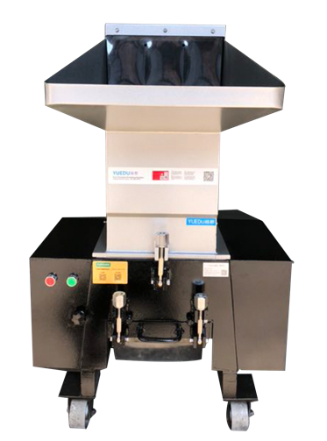 | 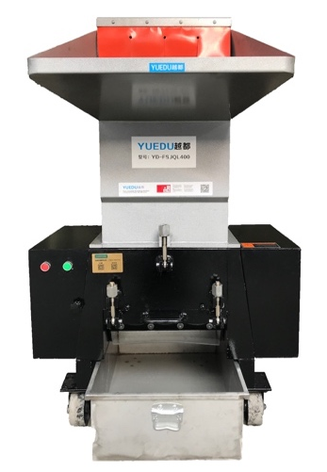 | 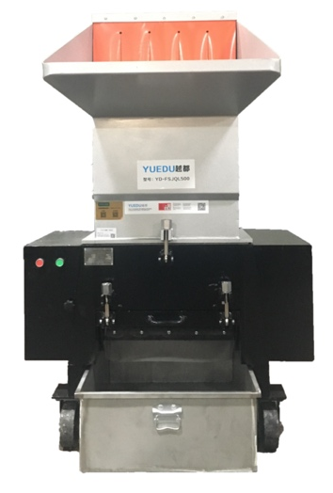 | 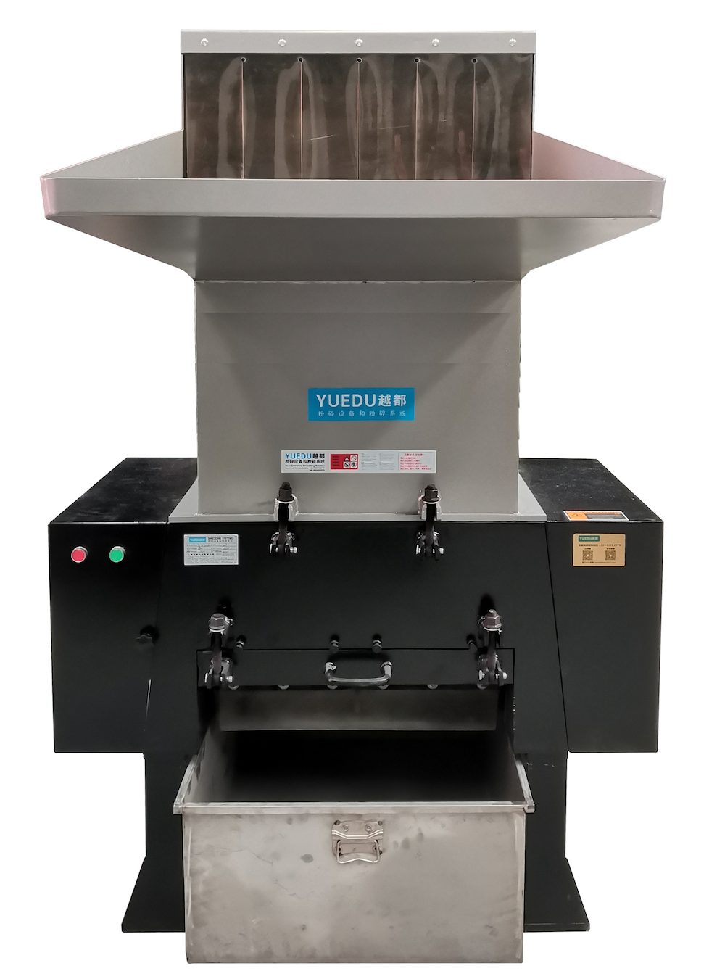
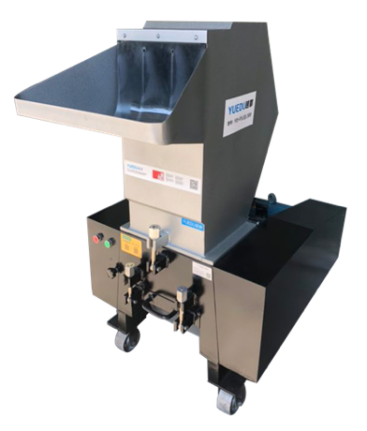 | 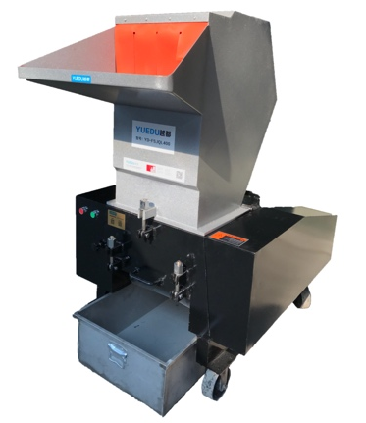 | 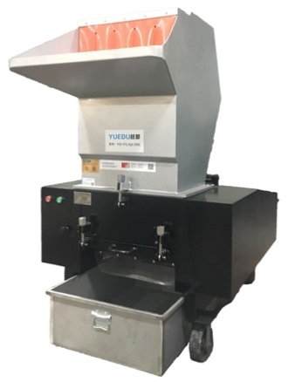 | 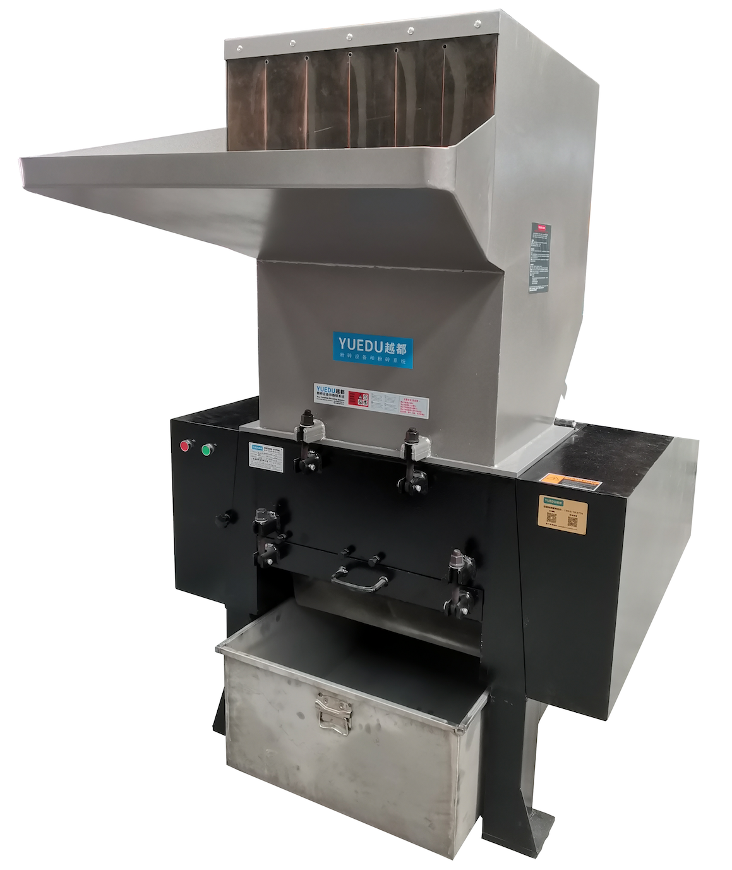
✅ 核心优势Key Features
●大马力  ●合金刀具 | ●符合EHS标准：符合环境、健康与安全标准。  ●大块机头料粉碎
🔧主要参数Technical Specifications
产品型号 | YD-FSJQL300 | YD-FSJQL400 | YD-FSJQL500 | YD-FSJQL600 | YD-FSJQL800
入口尺寸(mm) | 310*260 | 410*260 | 510*260 | 610*310 | 810*410
碎纸张数 | 30-50张 | 70-80张 | 100-150张 | 200-300张 | 400-800张
粉碎能力（kg/h） | 100-200 | 150-250 | 200-350 | 300-600 | 500-800
电机功率 | 5.5KW, 380V | 7.5KW, 380V | 11KW, 380V | 15KW, 380V | 30KW, 380V
出料（可定制） | 8mm | 8mm | 8mm | 8mm | 8mm
产品尺寸（m） | 1.22x0.72x1.16 | 1.32x0.86x1.46 | 1.45x1.00x1.54 | 1.70x1.15x1.88 | 2.22x1.38x2.38
重量（kg） | 450 | 550 | 750 | 850 | 2000
产品售价（含税） | 15847 | 19781 | 23929 | 38423 | 79618

📄（7/7）YD-SL500 | 600 | 700 Silent High-Power Shredder
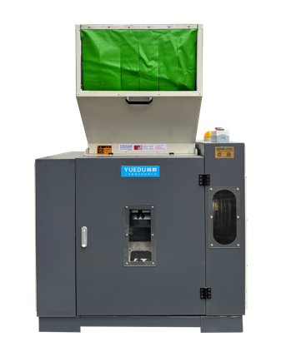 | 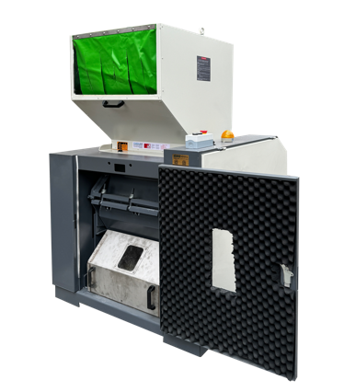 | 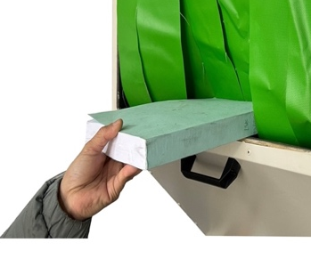 | 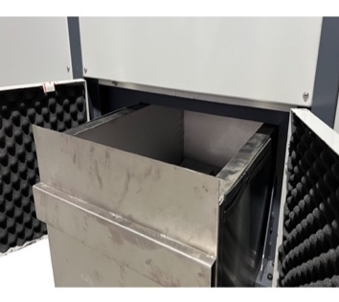
Front View | Internal View | Safe Feeding Inlet | Fully Enclosed Waste Bin
🏆Twenty Years of Design Expertise, Proven Client Applications, and Innovative Global Technologies
As a pioneering new product, it integrates two decades of engineering excellence, extensive client application cases, and globally innovative technology. Features include but are not limited to:
● EHS-Compliant: Fully aligned with global Environmental, Health, and Safety standards, trusted by multinational corporations.  ● High Efficiency, Low Energy Consumption: Saves costs while delivering exceptional performance.  ● Zero Leakage: No material leakage, no dust emissions, and no material return during operation. | ● Handles Extreme Materials: Suitable for ultra-thick and super-hard materials.  ● Adaptable to Low-Melting Plastics and Rubber: Ideal for processing heat-sensitive materials.  ● Compatible with Glass Fiber and Mineral Materials: Designed for tough, abrasive substances.
🌍Preferred by Industry Leaders
The first choice for multinational corporations, industry leaders, and Fortune Global 500 enterprises.
🔧Technical Specifications:
Product Model | YD-SL500 | YD-SL600 | YD-SL700
Inlet Dimensions (mm) | 400*250 | 500*260 | 600*300
Number of Sheets Shredded | 150-250 | 300-500 | 400-600
Shredding Capacity | 200-350 kg/h | 300-600 kg/h | 400-600kg/h
Motor Power | 7.5KW, 380V | 11KW, 380V | 15kw, 380V
Shredded Size(Customizable) | 8mm | 8mm | 8mm
Dimensions (mm) | 1240*1000*1563 | 1395*1160*1689 | 1550*1230*2350
Weight (kg) | 450 | 700 | 900
Pricing RMB | 67669 | 82715 | 97761

表格中粉碎张数为首次投料的张数，机器长期工作时，每次应均匀投料，待粉碎腔体中物料粉碎完毕后，再进行投料操作，如果连续投料，建议每次投料塑料为表格中数值的1/3以内。
该粉碎能力为最大值，比如粉碎硬质塑料类物料；如果粉碎纸张，粉碎能力会打折，粉碎产量与出料尺寸有关（粉碎尺寸越大，出料越快），如果粉碎纸张，建议粉碎为3cm尺寸速度较快，粉碎能力约为表格中最大粉碎数值的1/3。
可定制3mm 5mm 8mm 15mm 18mm 25mm 28mm 等规格尺寸，出厂标配为8mm尺寸，更多信息详询公司客服。
For Long-Term Operation: Feed materials evenly and wait until the materials in the shredding chamber are fully processed before adding more. For continuous feeding, ensure each batch is no more than one-third of the value specified in the table.
Shredding Capacity: The listed capacity is the maximum, applicable to hard plastics. For materials like paper, the shredding capacity decreases and depends on the output size (larger sizes process faster). For shredding paper, a 3 cm output size is recommended for faster processing.
Customizable Sizes: Available in 1mm, 3mm, and 5mm specifications. For additional options, please contact customer service.

